General

* Move the not-used table to a subfolder named “not used” or so…
  + Visit, visit_temp, hospital,physocoams

Patient Table

* Added email, phone number, gender column in ER diagram
* Deleted City column in ER diagram

Insurance Table

* Get confused of health_insurance, insurance_table, insurance_hospital_table
* 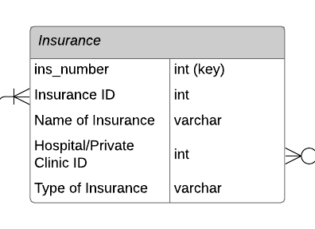
* The insurance table links to retrieve hospital/clinic that insuranceID patient provide
* What does type mean in .cvs table?
* If we use InsuranceID as the key finder, does this mean we need a huge data set? Each person has one unique id. In our dataset we need to list N(number) rows of hospital/clinic would take insurance
* Insurance ID - insurance company & find type - then retrieve hospital/clinic ID?

Visit_Table

* Delete procedure_id column in .cvs & ER
* What does id mean in .cvs? Patient visit id???? The number is huge and not continuous, can we start 1 and 1 +=?
* Moved doctor rating to doctor table in ER

Hospital_Table

* Good to me

Drug_condition

* Changed function to condition in ER to match .cvs

Disease_table & Disease_drug_table

* 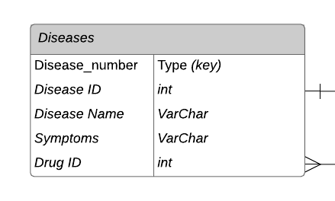
* One disease can have diff drug ID
* Above is our old diseases table, if disease_num is auto generate it brings trouble to find if One disease can have diff drug ID
  + Deleted disease_number in ER, key is Disease ID

- merge Disease_table & Disease_drug_table in .cvs

- - Add symptoms column in .cvs

Treatment_table

* Sorry for misleading this morning on treatment table
* The length of the treatment table needs to be the same as the length of the patient visiting because of special comments/descriptions provided, drug, quantity...
* The activity is limited
* Add Drug ID, quantity column in .csv

Physicians/doctors_table

* Add doctor rating, hospital name column in .cvs
* Can we understand the department describe the same thing in the specialty of a hospital/clinic table? Department originally is designed for doctors who worked in hospitals. ????

Nurse_table

* Add doctor rating, hospital name column in .cvs
* Can we understand the department describe the same thing in the specialty of a hospital/clinic table? Department originally is designed for doctors who worked in hospitals. ????